**SPRINT -4**

|  |  |
| --- | --- |
| **TEAM ID** | PNT2022TMID08747 |
| **PROJECT DOMAIN** | Internet of Things |
| **PROJECT NAME** | IoT Based Smart Crop Protection System for Agriculture |

Create a User Interface in MIT app Inventor:

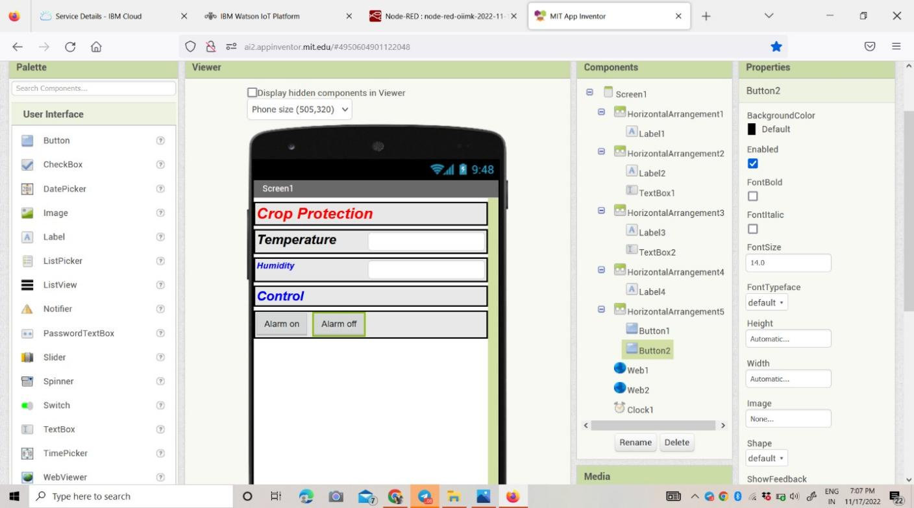

Building a blocks to connect with Node red and Mobile app:

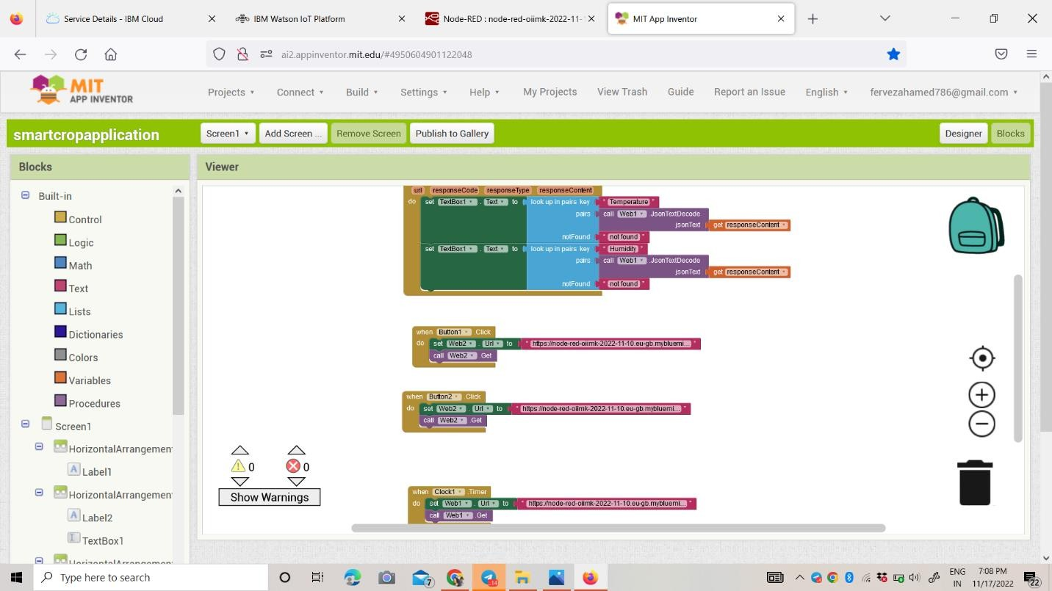

Check with the mobile app to work the flow Node Red:

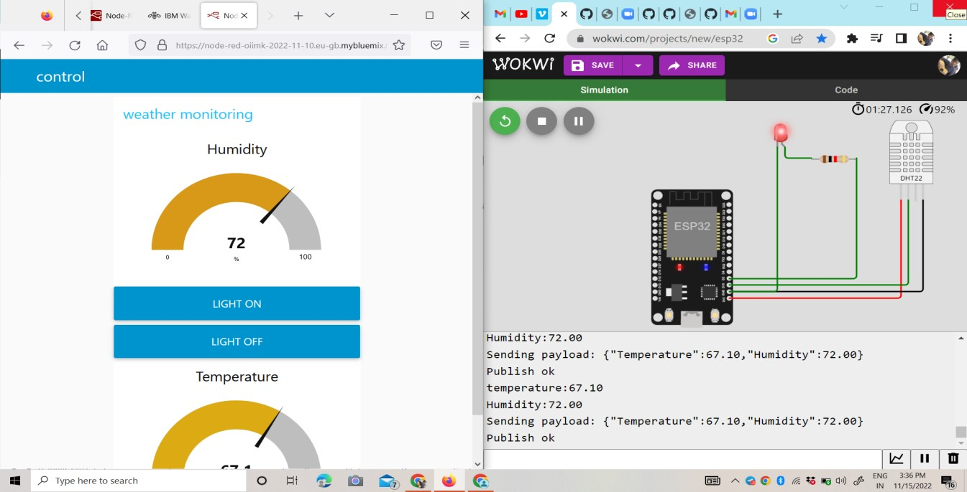

Mobile Application Interface:

